Password Manager Project Specification

Abstract
This project will consist of 2 different parts, a server and a front-end. The front-end will be packaged in two forms, a standalone Electron wrapper for many distributions, including Linux, Mac and Windows, and a progressive web application which allows background syncing. There will be no differences in the code between the progressive app and the Electron front end. The server’s job will be to facilitate the users and host the progressive web application. The application will primarily allow users to store and generate high entropy passwords securely with 2 secure backup solutions.

Cryptography Methods
There will be several encryption methods that will be used in the program. Most importantly, the password manager will feature a private advanced recovery and authentication options not commonly found in other password managers.

Cryptographic container
The cryptographic container will be a Linux Unified Key Setup (aka LUKS) like container for the database and the main encryption key (cryptsetup, 2020) as described by Figure 1. Each slot requires a password meaning multiple passwords can unlock the encrypted data. This could in theory mean that two separate people with two separate passwords could unlock this container given they both had valid passwords. This, of course, becomes not optimal if there are many people that could want access to the container. Because of this, it’s likely that not many users will use this function.
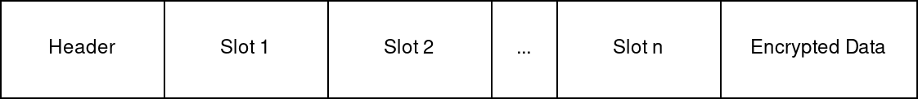Figure 1: Database container example.

Architecture details
The header will contain all the necessary information in regards to the slots that house the master key and the storage on the device. The slots contain a copy of the secret master key, the PBKDF2 salt, the PBKDF2 iteration count and the PBKDF2 hashing algorithm name. Unlike LUKS, the user can have an unlimited (within reason) number of slots, with a minimum of 0 slots. This is by design. Each slot will require a unique password to open. The user will be able to remove or add slots at will. The user will be able to change the number of iteration count only to a higher number, preventing password decay.

Shared secret recovery option
(Adi Shamir, 1979) describes a solution where secret data is split into parts and a threshold where number of pieces are required to recover the passwords (where , and where are random integers and where , and , and is any where ). The only criticism of this paper would be when an attacker gains , it becomes increasingly easier for the attacker to predict what the polynomial is, thus figuring out the solution. This is because of the smooth and predictable nature of polynomials, this is shown in Figure 2. A simple modification can be made to Shamir’s scheme to make it resistant to this type of attack. A prime and threshold should be chosen such, , and should be updated to . The result of this modification can be seen in Figure 3.
Figure 2: Pure Shamir Scheme shows straight line (on logarithmic y-scale) | Figure 3: Shamir Scheme with mod p shows no pattern in points for the same domain.
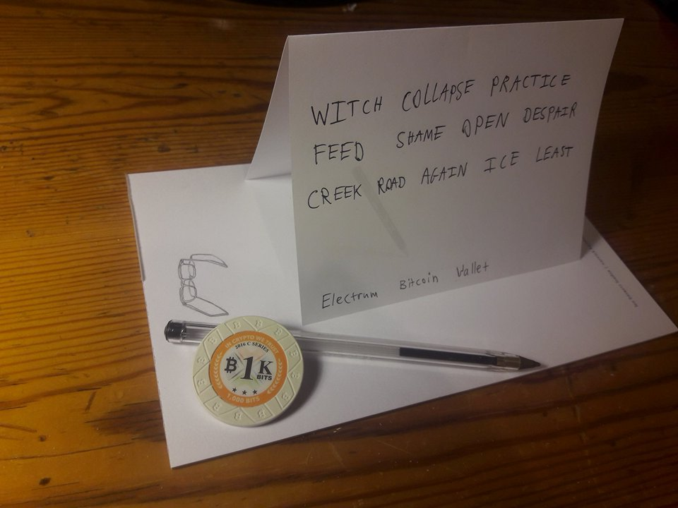Figure 4: Example recovery seed phrase on paper
By using this, it’s possible to create a virtual slot that won’t be present in the container which would be able to decrypt encrypted data. This virtual slot would be and the user would be able to divide them into pieces and set the threshold of as they desire. The output of each piece would be something similar to the image in Figure 4.

Server
The server will provide many services for the users. The user will be able to configure their own servers to use if they so desire, but one will be provided for users without technical skill.

Entropy generation service
For devices that are low entropy, for people that do not trust their own entropy, or devices where entropy generation would take a long time, an entropy generation service can be provided for such cases. Large numbers of entropy could be generated from something as simple as lava lamps as shown in (Tom Scott, 2017) and described in (Joshua Liebow-Feeser, 2017).

Point to IPs
For devices that do not have a static IP address, a solution can be used where the service can point to the other devices’ public IP address. This allows for connections to occur directly without going through the web server. This solution increases privacy and lowers bandwidth used by the server.
This service will keep pings sent from the devices and the time the device has pinged back to the server and keep them to allow proper syncing. To increase privacy and to protect individuals, the data will be fully encrypted by the individual's master key.

Middle-point
For devices that cannot connect directly to each other, the sever will need to facilitate users to tunnel traffic through the server to their devices. This will make the server act as a relay and allow devices to connect behind strict firewalls. The data passing through the server will be device-to-device encrypted. This means that there will be no visible data being transferred over the server - moreover, if the server gets taken over by an adversary they will only gain the IP addresses of the connections.

Application
The application will provide the storage and the front-end interfaces for the user. The storage will be securely encrypted on the device and will be inaccessible when the password manager is not in use.

Password Database
The application will keep it’s own version of the database of passwords as well as the metadata associated with them. The user will be able to add any metadata associated with a password. This includes fields that they define. The default fields will be:
- Website Name
- Website URL
- Password
- Username
The application will utilise the localStorage Web API (Mozilla, 2021) which allows up to 5MB of storage to be used. In internal experimental testing, a typical user exported Firefox Lockwise passwords to a CSV file. There were in total 304 passwords contained in the file. Uncompressed passwords exported from Firefox Lockwise only took 54 KiB (exactly 55,369 bytes) of storage.
Figure 5: Password exhaustion calculation
Figure 5 gives an estimate that more than 27,452 passwords would exhaust the 5MB limit, which realistically no user would reach given the user has been using the password manager (with a migrated password list from another password manager) for 5 years. This means that this limitation is only likely to occur in very specific scenarios (e.g. user tries to add a thousands of passwords).

Sync Activity
The application will sync automatically when there is internet access. The sync will be done via the most optimal and secure route that the algorithm chooses. The algorithm will prioritise retrieving data in the following order:
- Locally
- Directly
- Via server
This ensure that data doesn’t go to places it doesn’t need to and makes sure that the server’s bandwidth load is low.

Extra features
Here are some additional supporting features that the password manager will have:
- Password Generator
- CSV export
- Manual sync
- Settings:
  - Server domain/ip
  - Sync times
  - Sync method order
  - Container encryption
  - Account overview

Bibliography
Adi Shamir (1979) ‘How to Share a Secret’, Massachusetts Institute of Technology, 22(11), pp. 612–613.
cryptsetup (2020) ‘Cryptsetup and LUKS - open-source disk encryption’, What the ...?, 21 December. Available at: https://gitlab.com/cryptsetup/cryptsetup (Accessed: 14 January 2021).
Joshua Liebow-Feeser (2017) ‘LavaRand in Production: The Nitty-Gritty Technical Details’, The Cloudflare Blog, 11 June. Available at: https://blog.cloudflare.com/lavarand-in-production-the-nitty-gritty-technical-details/ (Accessed: 14 January 2021).
Mozilla (2021) ‘Window.localStorage’, MDN Web Docs, 11 January. Available at: https://developer.mozilla.org/en-US/docs/Web/API/Window/localStorage (Accessed: 14 January 2021).
Tom Scott (2017) ‘The Lava Lamps That Help Keep The Internet Secure’, 6 November. Available at: https://www.youtube.com/watch?v=1cUUfMeOijg (Accessed: 14 January 2021).
Table of Figures
Figure 1: Database container example. 1
Figure 2: Pure Shamir Scheme shows straight line (on logarithmic y-scale) 2
Figure 3: Shamir Scheme with mod p shows no pattern in points for the same domain. 2
Figure 4: Example recovery seed phrase on paper 2
Figure 5: Password exhaustion calculation 4

